LAB 09:
Question#01:
Code:
#include <iostream>
using namespace std;

// Abstract base class
class ArrayMultiplier
{
public:
virtual void calculate() = 0; // Pure virtual function
};

class ArrayMultiplier1D : public ArrayMultiplier
{
int arr[10];
int size;

public:
ArrayMultiplier1D(int a[], int n)
{
size = n;
for (int i = 0; i < size; i++)
arr[i] = a[i];
}

void calculate() override
{
int result = 1;
for (int i = 0; i < size; i++)
result *= arr[i];
cout << "1D Array Multiplication Result: " << result << endl;
}
};

class ArrayMultiplier2D : public ArrayMultiplier
{
int arr[10][10];
int rows, cols;

public:
ArrayMultiplier2D(int a[][10], int r, int c)
{
rows = r;
cols = c;
for (int i = 0; i < rows; i++)
for (int j = 0; j < cols; j++)
arr[i][j] = a[i][j];
}

void calculate() override
{
int result = 1;
for (int i = 0; i < rows; i++)
for (int j = 0; j < cols; j++)
result *= arr[i][j];
cout << "2D Array Multiplication Result: " << result << endl;
}
};

int main()
{

int a[] = {1, 2, 3, 4};
ArrayMultiplier1D obj1(a, 4);
obj1.calculate();

int b[2][10] = {{1, 2, 3}, {4, 5, 6}};
ArrayMultiplier2D obj2(b, 2, 3);
obj2.calculate();

return 0;
}

Output:
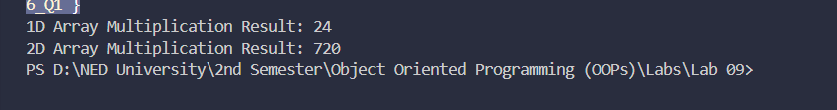

Question#02:
Code:
#include <iostream>
using namespace std;

// Abstract base class
class Store {
protected:
double total_bill;

public:
Store(double bill) {
total_bill = bill;
}

virtual void calculateFinalBill() = 0; // Pure virtual function
};

// Derived class for ImtiazStore (7% discount)
class ImtiazStore : public Store {
public:
ImtiazStore(double bill) : Store(bill) {}

void calculateFinalBill() override {
double discount = total_bill * 0.07;
double final_bill = total_bill - discount;
cout << "ImtiazStore - Total Bill: " << total_bill << endl;
cout << "ImtiazStore - Discount (7%): " << discount << endl;
cout << "ImtiazStore - Final Bill: " << final_bill << endl;
}
};

// Derived class for BinHashimStore (5% discount)
class BinHashimStore : public Store {
public:
BinHashimStore(double bill) : Store(bill) {}

void calculateFinalBill() override {
double discount = total_bill * 0.05;
double final_bill = total_bill - discount;
cout << "\nBinHashimStore - Total Bill: " << total_bill << endl;
cout << "BinHashimStore - Discount (5%): " << discount << endl;
cout << "BinHashimStore - Final Bill: " << final_bill << endl;
}
};

int main() {
ImtiazStore store1(5000);
store1.calculateFinalBill();

BinHashimStore store2(5000);
store2.calculateFinalBill();

return 0;
}

Output:
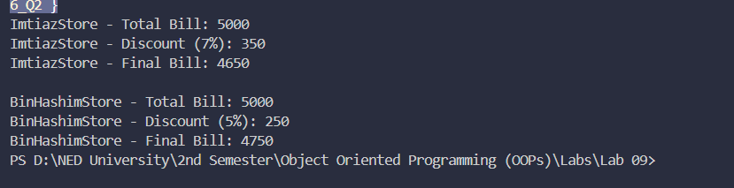

Question#03:
Code:
#include <iostream>
#include <string>
using namespace std;

// Abstract Base Class
class Vehicle {
protected:
int carId;
string brand;
string model;

public:
Vehicle(int id, string b, string m) {
carId = id;
brand = b;
model = m;
}

virtual bool isAvailable() = 0; // Pure virtual function
virtual void rent() = 0; // Pure virtual function
virtual void returnVehicle() = 0; // Pure virtual function

void displayInfo() {
cout << "Car ID: " << carId << " | Brand: " << brand << " | Model: " << model;
}

virtual ~Vehicle() {} // Virtual destructor
};

// Derived Class: Car
class Car : public Vehicle {
bool available;

public:
Car(int id, string b, string m) : Vehicle(id, b, m) {
available = true; // Car is available by default
}

bool isAvailable() override {
return available;
}

void rent() override {
if (available) {
available = false;
cout << "Car rented successfully -> ";
displayInfo();
cout << endl;
} else {
cout << "Car not available -> ";
displayInfo();
cout << endl;
}
}

void returnVehicle() override {
available = true;
cout << "Car returned successfully -> ";
displayInfo();
cout << endl;
}
};

// Rental System Class
class RentalSystem {
public:
void rentVehicle(Vehicle* v) {
if (v->isAvailable()) {
v->rent();
} else {
cout << "Sorry, this vehicle is not available for rent!" << endl;
}
}

void returnVehicle(Vehicle* v) {
v->returnVehicle();
}
};

// Customer Class
class Customer {
string name;
RentalSystem rs;

public:
Customer(string n) {
name = n;
}

void rentVehicle(Vehicle* v) {
cout << "\n" << name << " is trying to rent a car..." << endl;
rs.rentVehicle(v);
}

void returnVehicle(Vehicle* v) {
cout << "\n" << name << " is returning a car..." << endl;
rs.returnVehicle(v);
}
};

// Main - Array of base class pointers with dynamic memory
int main() {
// Array of base class pointers with dynamic memory allocation
Vehicle* fleet[3];
fleet[0] = new Car(101, "Toyota", "Corolla");
fleet[1] = new Car(102, "Honda", "Civic");
fleet[2] = new Car(103, "Audi", "r8");

// Display all cars
cout << "===== Available Cars in Fleet =====" << endl;
for (int i = 0; i < 3; i++) {
fleet[i]->displayInfo();
cout << " | Status: " << (fleet[i]->isAvailable() ? "Available" : "Rented") << endl;
}

// Customers
Customer c1("Ali");
Customer c2("Faarid");

// Rent operations
c1.rentVehicle(fleet[0]); // Ali rents Toyota Corolla
c2.rentVehicle(fleet[0]); // Sara tries to rent same car (not available)
c2.rentVehicle(fleet[1]); // Sara rents Honda Civic

// Return operations
c1.returnVehicle(fleet[0]); // Ali returns Toyota Corolla
c2.rentVehicle(fleet[0]); // Sara rents it again

// Display final status
cout << "\n===== Final Fleet Status =====" << endl;
for (int i = 0; i < 3; i++) {
fleet[i]->displayInfo();
cout << " | Status: " << (fleet[i]->isAvailable() ? "Available" : "Rented") << endl;
}

// Free dynamic memory
for (int i = 0; i < 3; i++)
delete fleet[i];

return 0;
}

Output:
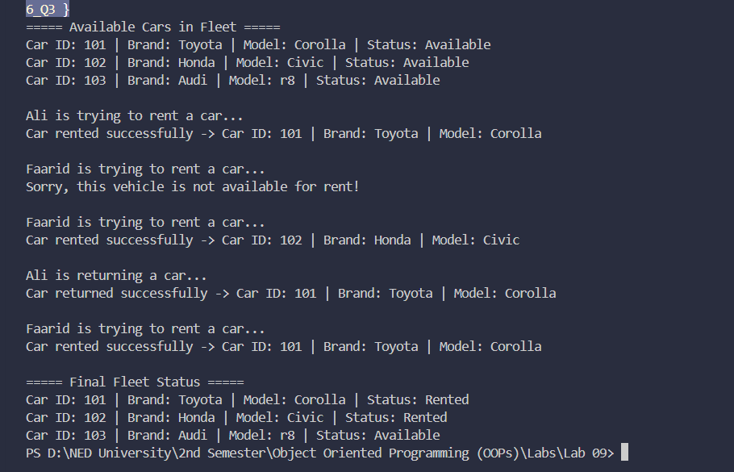

Question#04:
Code:
#include <iostream>
#include <string>
using namespace std;

// Abstract Base Class
class EncryptionTechnique {
protected:
string message;

public:
EncryptionTechnique(string msg) {
message = msg;
}

virtual void encrypt() = 0; // Pure virtual function
};

// Derived Class: EncryptionTechnique1
// Converts each alphabet to its ASCII code
class EncryptionTechnique1 : public EncryptionTechnique {
public:
EncryptionTechnique1(string msg) : EncryptionTechnique(msg) {}

void encrypt() override {
cout << "Technique 1 Encrypted Message: ";
for (int i = 0; i < message.length(); i++) {
cout << (int)message[i];
}
cout << endl;
}
};

// Derived Class: EncryptionTechnique2
// Converts each alphabet to its ASCII code and adds 2
class EncryptionTechnique2 : public EncryptionTechnique {
public:
EncryptionTechnique2(string msg) : EncryptionTechnique(msg) {}

void encrypt() override {
cout << "Technique 2 Encrypted Message: ";
for (int i = 0; i < message.length(); i++) {
cout << (int)message[i] + 2;
}
cout << endl;
}
};

int main() {
string input;
cout << "Enter message to encrypt: ";
cin >> input;

EncryptionTechnique* e1 = new EncryptionTechnique1(input);
EncryptionTechnique* e2 = new EncryptionTechnique2(input);

e1->encrypt();
e2->encrypt();

delete e1;
delete e2;

return 0;
}

Output:
